

Contents Page

Document Version 1

1. Purpose 2

1.4. Definitions and Acronyms 2

2. Overall System Description 3

2.3. Functional Requirements 5

# Document Version

| No | Update | Name | Date | Version |
| --- | --- | --- | --- | --- |
| 1. | Initial version | Gabriel |  | 1.0 |
| 1.1 | Initial version | Kevan |  | 1.1 |
| 1.3 | Initial version | Ivan |  | 1.3 |
| 1.4 | Initial version | Gabriel |  | 1.4 |
| 1.5 | Initial version | Kevan |  | 1.5 |
| 1.6 | Initial version | Ivan |  | 1.6 |

# 1. Purpose

* 1. Intended Audience

Fire-breakouts have been occurring as of late in HDB apartments. These breakouts especially in apartments where the elderly live alone. Such cases could have been prevented with a system that helps detect early stages of fire.

* 1. Intended Use

The project is designed to be placed in homes of elderly people who live alone, as well as any other homes that wish to install the system. The system detects potential causes of fire using a (1)LDR to detect smoke being emitted by the fire by blocking it, (2)a camera using AI system to detect a fire, and (3)a DHT11 that detects the sprinkler’s activation(controlled by by the increase in humidity. If any of the above sensors activates, a 24/7 IoT system will then collect the sensor’s reading data, and tweet out a tweet notification on X(Twitter), alerting SCDF of the fire outbreak

## 1.3. Definitions and Acronyms

| **Acronym** | **Description** |
| --- | --- |
| DHT11 | DHT11 Temperature & Humidity Sensor |
| Cam | Camera |
| LDR | Light Dependant Resistor |
| M | Motor |
| SM | Servo Motor |
| LED | Light Emitting Diode |
| Buz | Buzzer |
| Notif | Notification Sender |
| SW | Software |
| HW | Hardware |

# 2. Overall System Description

2.1. Use Case Diagrams



2.2. System Architecture

## 2.3. Functional Requirements

| **REQ_ID** | **Requirement** |
| --- | --- |
| REQ-01 | **Check sensors for changes.**   * Temperature sensors * Visual sensors * Light sensors * Smoke detectors |
| REQ-02 | If one of the sensors detect a change (etc increase in temp/smoke/light).   * Enable Alarm. |
| REQ-03 | If two of the sensors detect a change.   * Enable Fire Suppression (sprinkler system) * Notify SCDF |
| REQ-04 | Manual Switch for fire detection   * Enable Fire Suppression (sprinkler system) * Notify SCDF |

Flow Chart for main system

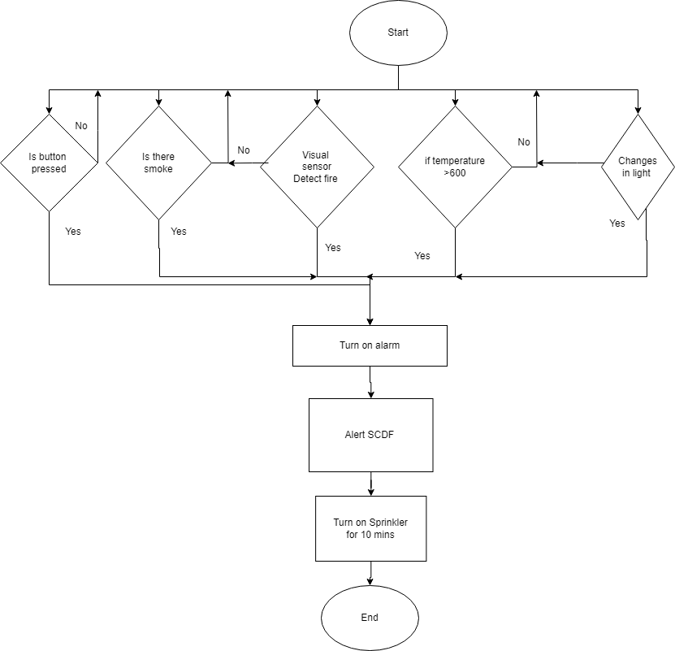

Flow Chart for AI Detection With Camera Fire AI

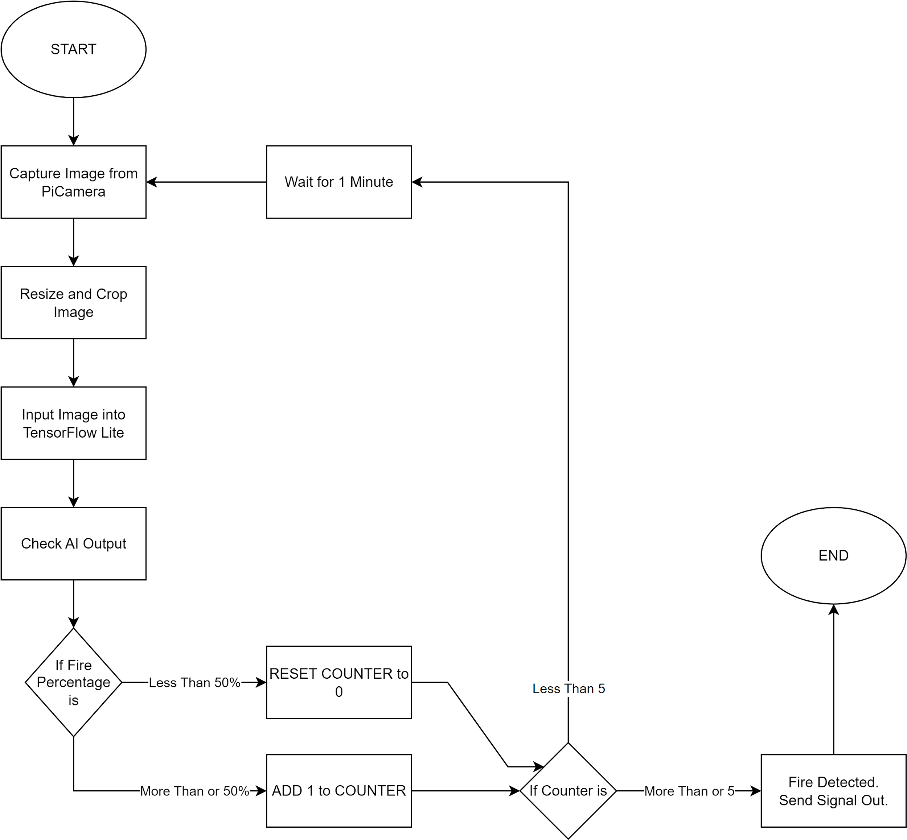

Flow Chart for Alerting SCDF

